iClinic Front Desk Assistant: Use Case, Requirements and Architecture (Website-Initiated Outbound Calls)
Problem, user story, requirements, and high-level and low-level design for Book a Call (AI outbound voice call) and Chat Booking. Draft for client approval.

1. Problem statement
Clinic front desks spend much of the day on the phone booking appointments. Patients want a fast booking, other times offered when their first choice is gone, and a clear confirmation.
The iClinic Front Desk Assistant is a conversational assistant that helps patients schedule appointments with a healthcare facility by talking to them naturally. In this scenario the patient never calls the clinic. The website offers two options:
- Book a Call: the patient fills in a short form and the application places an AI voice call to the patient to book the appointment.
- Chat Booking (Phase 2): the same booking capability in a chat interface.
The application always initiates the voice call. There is no inbound voice calling.
The Book a Call form collects the patient's name, phone number, date of birth, appointment requirement, and preferred provider, date and time.
The assistant only books appointments. It never gives medical advice. Provider schedules, working hours, breaks, time off, slot generation and slot blocking stay manual with the front desk in Phase 1. The assistant only reads available slots from the clinic's schedule source, which for this project is the sample clinic schedule.
What we are solving:
- Move routine booking conversations from the front desk to the assistant.
- Offer alternate slots when the requested slot is not available.
- Confirm the booking in the conversation and by SMS and/or email.
- Log every request, call and conversation, and never leave a half-made or double booking.

2. User story and business impact

2.1 User stories
Who | Story
Patient, Book a Call | As a patient, I ask for a call on the website with my basic details to book a call (no much details) . The assistant calls me, confirms who I am with my full name and date of birth, offers slots, accepts my corrections without starting over, and I get a confirmation in the call and by SMS or email.
Patient, Chat Booking (Phase 2) | As a patient, I book through chat with the same capabilities as on the call.
Front desk staff | As front desk staff, I want routine booking handled for me so I only deal with exceptions. When the assistant cannot finish a booking, I can see what happened in the log and take over.  If the outbound call not pick or any issue I need to get the data , I want to know how many calls occurred till now in the queue list

2.2 Business impact
- Less front desk time spent on routine scheduling conversations.
- Faster booking, with alternate slot suggestions instead of a dead end.
- A clear confirmation in the conversation and by SMS and/or email, with date, time, provider, location, appointment type and instructions.
- Every request, call and conversation has a full state and step-by-step log, with bookings, calls and conversations screens that staff can filter and sort.
- No half-made or double bookings.

2.3 What we cannot guarantee
Every request creates a call task, but we cannot guarantee that the patient answers, or that the call starts the moment the form is submitted. The patient may not answer, may be busy, or a voicemail may pick up. Calls from an international number may be flagged as spam on Indian phones, which lowers answer rates. Capacity is also finite at the telephony provider, the real-time voice layer, the AI providers and the servers. When capacity is full, call tasks wait in a queue and are placed as capacity frees up, so the patient may wait longer for the call.
We reduce the impact in four ways:
- Retry within the calling rules, and log every attempt.
- After the last attempt, hand the request to the front desk with a logged outcome.
- Size capacity for the busy hour with a buffer, and alert at about 80 percent of capacity.
- Never leave a half-made booking when a call fails.
The calling window, retry rule and concurrency target are client decisions (see sections 3.5 and 4.5).

3. Requirements

3.1 Use cases and requirements
Use case | Channel | Phase | Requirements
UC-1 Request a call on the website and book through the AI outbound call | Website and voice | 1 | FR-1, FR-3 to FR-12
UC-2 Book an appointment through chat | Website and chat | 2 | FR-2, FR-13, FR-14, and the booking requirements FR-7 to FR-12

ID | Requirement | Phase
FR-1 | Book a Call: the website offers a form (name, phone number, date of birth, appointment requirement, preferred provider, date and time), and the application places an AI voice call to the patient | 1
FR-2 | Chat Booking: the website also offers a chat interface with the same booking capability | 2
FR-3 | The backend creates and manages an outbound call task for each valid request: dial rules, queue, retries and opt-out. A duplicate submission does not create a second call | 1
FR-4 | The telephony provider places the call and reports call status (ringing, answered, no answer, busy, voicemail, failed) to the backend | 1
FR-5 | When the patient answers, the call connects to LiveKit, which runs the real-time voice session, and the AI agent joins | 1
FR-6 | Voice flow: the agent introduces itself as automated, verifies identity, understands the appointment requirement, checks slots, reconfirms, books, confirms and logs the outcome | 1
FR-7 | Identity verification with full name and date of birth. Wrong person, failed verification and stop-calls requests are handled as in sections 4.4 and 5.6 | 1
FR-8 | Natural conversation: interruptions, corrections (date, time, provider, type) and natural language | 1
FR-9 | Offer available slots from the clinic's schedule input | 1
FR-10 | Alternate slots when the request is unavailable: nearest times, same provider, next provider if the patient allows | 1
FR-11 | Reconfirm date and time, provider, location and appointment type, then book atomically and confirm in the conversation | 1
FR-12 | SMS and/or email confirmation with date and time, provider, location, appointment type and instructions | 1
FR-13 | Context-aware chat flow: greeting, appointment reason, suggest types, suggest slots, confirm booking, confirmation | 2
FR-14 | Minimum booking inputs: reason, type, preferred date and time, provider preference, patient identification | 2
Chat Booking shares the same booking tools, rules, confirmation and logging as the call.
Common requirements:
- Call task and call state log: every request has a call task with its call state and every attempt logged with date and time (queued, dialling, ringing, answered, no answer, busy, voicemail, failed, retry scheduled, opted out).
- Conversation state log: every call conversation and chat has a record (channel, patient, start time) and a state, with every change logged with date and time.
whats the agent speaks whats the reply of the human all needed to be noted.
- Step-by-step log: each step logs input, output, time taken and result (success, warning or error). Staff can open any conversation and see its timeline and transcript.
- Errors: every step handles its own errors. Nothing fails silently, and the assistant never crashes or hangs up without explanation. A failed conversation never leaves a half-made booking.
- Screens: bookings, calls, conversations and log screens with filters (channel, date range, provider, appointment type, location, call state, conversation state, confirmation status) and sorting (appointment date, booking time, provider, state).

3.2 Success criteria
Acceptance criteria
- Phase 1: a patient can submit Book a Call and the assistant completes the booking end to end through the AI outbound call.
- If the requested slot is unavailable, the assistant offers alternates and completes the booking.
- Booking supports corrections and interruptions without restarting.
- No answer, busy, voicemail, wrong person, failed identity, call failure and stop-calls cases are handled and logged, with no half-made booking.
- The patient receives an SMS/email confirmation with accurate details and instructions.
- Phase 2: a patient can book end to end through chat with the same capabilities.
Measures
Measure | Target
Requirements FR-1 to FR-14 met | All
Phase 1 and 2 acceptance criteria met | All
Bookings with correct details compared with the request | 100%
Confirmations with all FR-12 details | 100%
Call tasks and conversations with full state and step-by-step log | 100%
Errors handled with a clear message | All
Half-made or double bookings | None
Running on the cloud | Working
Scenarios to demonstrate:
# | Scenario | Phase
1 | Book a Call, preferred slot available: booked, confirmed in the call and by SMS/email | 1
2 | Book a Call, preferred slot unavailable: alternates offered, booking completed | 1
3 | Book a Call, patient corrects date, time or provider mid-flow | 1
4 | No answer or busy: state logged, retry scheduled, front desk after the last attempt | 1
5 | Voicemail or wrong person answers: no details revealed, logged, retry later | 1
6 | Identity cannot be confirmed: no booking, logged, handed to front desk | 1
7 | Patient asks to stop calls: opt-out recorded, no further calls | 1
8 | SMS fails after booking: automatic retry, then email, failure logged and flagged | 1
9 | Call drops or booking system fails: no half-made booking, logged, handed to front desk | 1
10 | Chat booking end to end, with alternates and corrections | 2

3.3 User journeys and flows
Book a Call
- Patient: opens the website, chooses Book a Call, enters name, phone number, date of birth, appointment requirement, and preferred provider, date and time, and submits.
- Website: collects the request, sends it to the backend, and tells the patient a call will follow.
- Backend: validates the request, creates the outbound call task and checks the dial rules.
- Telephony provider: places the call to the submitted number and reports call status.
- Patient: answers the phone.
- LiveKit: when the call connects, starts the real-time voice session and the AI agent joins.
- Agent: introduces itself as automated and asks for the patient. If a different person answers, it reveals nothing and ends the call.
- Agent: verifies full name and date of birth. If identity is not confirmed, there is no booking and the case goes to the front desk.
- Agent: confirms the appointment requirement and preferences, the agent need to have a proper conversation I mean if they talk , the agent needs to console them talk with empathy , literaly comforts them .so that they feel comfortable , the agent should not give medical advice or anything it should address the issue the patient saying and give proper answers for the question they ask and for booking offers slots or alternates, accepts corrections, reads back and waits for a clear yes.
- Agent: books the slot, confirms in the call, sends the SMS/email confirmation, and the outcome is logged.
Chat Booking (Phase 2)
- Greeting, then the appointment reason, then suggested appointment types.
- Patient identification, then suggested available slots, with alternates and corrections.
- Booking confirmed in chat, and the SMS/email confirmation sent.

3.4 In scope and out of scope
In scope
- A website with two options: Book a Call and Chat Booking.
- Book a Call (Phase 1): form, backend call task, telephony call, real-time voice session and AI agent.
- Chat Booking (Phase 2), sharing the same tools, rules, confirmation and logging.
- Slot suggestion, alternate slots, corrections and interruptions.
- Identity confirmation with full name and date of birth on every channel.
- Confirmation in the conversation and by SMS and/or email, with retry.
- Call task and call state log, conversation state log, step-by-step log, error handling, and staff-only screens with filters and sorting.
- Cloud deployment, English only, sample clinic and patient data only.
Out of scope
- Inbound voice calling: the patient does not call the clinic.
- Provider schedule setup, working hours, breaks, time off, slot generation and slot blocking (manual, front desk).
- Medical advice of any kind.
- Calendar sync and staff notification (Phase 3, stretch goal).
- Waitlist, reminders and campaign calls.
- Cancellation and changes after confirmation, which go to the front desk.
- Real patient data, and calls or messages to anyone other than test contacts.
- Public deployment.

3.5 Assumptions and constraints
Assumptions
- One clinic with multiple locations or single location, English only, existing sample patients only.
- The submitted form is the authorising source for the call, and it is recorded on the call task.
- Identity is full name and date of birth on every channel. The phone number on the form is never proof of identity.
- Static sample schedule. Slot conflicts are shown using two parallel test sessions.
- Confirmation order is SMS first, then retry, then email, then flag.
- The agent introduces itself as automated.
- Dashboard for the front desk to manage all the booking which the agent does and track it , track the missing this , unanswered calls , diverted things
- Dial rules: place a call only if the request is valid and recorded, the patient is on the sample list, the number is a valid test number, the appointment requirement is administrative (never a diagnosis), it is inside the calling window, retries are left, and there is no opt-out.
- Default calling window and retry rule: 9:00 to 18:00, up to 3 attempts, at least 2 hours apart (client to confirm).
Technical constraints and challenges
Area | Challenge | How we handle it
Concurrent calls | Capacity is finite at the telephony provider, LiveKit, AI providers and servers | Queue call tasks, size for the busy hour with a buffer, alert at about 80 percent
Phone number | Twilio does not offer Indian numbers, so the prototype places calls from a US +1 number. Calls to Indian numbers must come from an international number and can be flagged as spam | Expect lower answer rates than a local number would give. Production would use an Indian provider connected to the same voice layer (registration and pricing to confirm)
Twilio trial account | Real-time streaming and SIP verbs are blocked, with 5 concurrent calls, 10 minutes per call and a 75-minute quota | A paid upgrade is needed before building the real-time agent
Provider callbacks | The provider reports call status to the backend and waits only a few seconds for answers | Keep the backend always on
Carrier reliability | Calls to India have had short incidents, including call errors and failures to one mobile network | Treat as call failure: log, retry within the rules, then front desk
SMS in India | Sender and template registration (DLT) is separate from voice and can be slow | Provider setup handled early (B4)
Form data | Name, phone number and date of birth are typed by whoever uses the site, so they are a claim, not proof | Identity is confirmed on the call, and a wrong person learns nothing
Provider approval | No voice, telephony, messaging, LLM or cloud service is assumed approved, and data regions are open | Mentor approval needed (B2)
Data constraints
- Only the sample clinic schedule and sample patient list are used. They are made up, and no real patient data is used.
- Calls, SMS and email go only to the provided test numbers and addresses, including form submissions in the demo.
- The schedule is a static input that the assistant only reads. If the schedule source is unavailable, the assistant tells the patient politely and logs it.
Grey areas that need a client decision
Area | Case | Proposed behaviour
Safety | Requirement or caller describes an emergency or asks a medical question | Stop the booking, refuse politely, point to emergency services or the front desk. Client approves the wording (B6)- approved this way
Safety | Patient is distressed or mentions self-harm | Respond with care and give crisis guidance. Script needs approval
Identity | Date of birth or full name is wrong | 2 tries, then no booking and handoff(indicate booking failure due to mismatch of data)
Identity | Booking for a family member | Verify the patient, not the person on the phone. Allowed or handoff? We handle this
Call | A different person answers | Reveal nothing, ask for the patient, end the call, retry later
Call | Voicemail | Leave no appointment or health details( we didn’t plan this)
Call | Patient says stop calling | Record an opt-out and make no further calls
Call | Calling window and retries | Default above. Request submitted outside the window: wait until it opens (O1)
Booking | Patient already has this appointment type | Mention it and ask. Allow a second booking?
Booking | Patient asks to change or cancel an existing appointment | We handle this we change the reschedule state and follow the procedure to book again for their convience with the available slot , make sure we again show the booked slot as available now
Handoff | What handoff means | Proposed: logged state plus a staff task, no live transfer (B7)
Confirmation | SMS and email both fail | Flag it, since the spoken confirmation is the only one received
Calls | Poor audio, repeated changes of mind, very long calls | Limit retries and loops, then offer handoff
System | LLM or speech timeout | Polite hold message, then handoff after a set timeout

4. High-level architecture
The application always starts the call, and each layer has one job. The proposed prototype stack is a telephony provider (Twilio) for the phone call and LiveKit for the real-time voice session. Provider choices are subject to mentor approval (B2).

4.1 Responsibilities
Layer | Responsible for | Does not
Website | Collects the patient's request for a call, and offers Chat Booking | Place calls or book appointments
Backend | Validates the request, creates and manages the outbound call task: queue, dial rules, retries, opt-out, call state log | Carry voice audio
Telephony provider | Places the phone call, manages telephone call status (ringing, answered, no answer, busy, failed), and connects the answered call to LiveKit | Run the conversation
LiveKit | Manages the real-time voice session after the call connects: one room per call, audio, agent dispatch | Act as the telephony provider or place the call
STT and TTS | STT converts the patient's speech to text. TTS converts the agent's reply to speech | Decide what to say
LangGraph | Conversation state, reasoning and the appointment workflow, and it calls the tools | Place the call or carry audio
Tools and database | verify_patient, get_slots, book_slot, send confirmation, over the sample patient list and clinic schedule | Manage calls
Messaging | SMS, retry, then email, then flag | Decide when to send
Staff dashboard | Shows call tasks, call states, conversations and flags, with filters and sorting | Change bookings

4.2 Book a Call architecture
The diagram below shows the Book a Call path from the website to the patient and back.
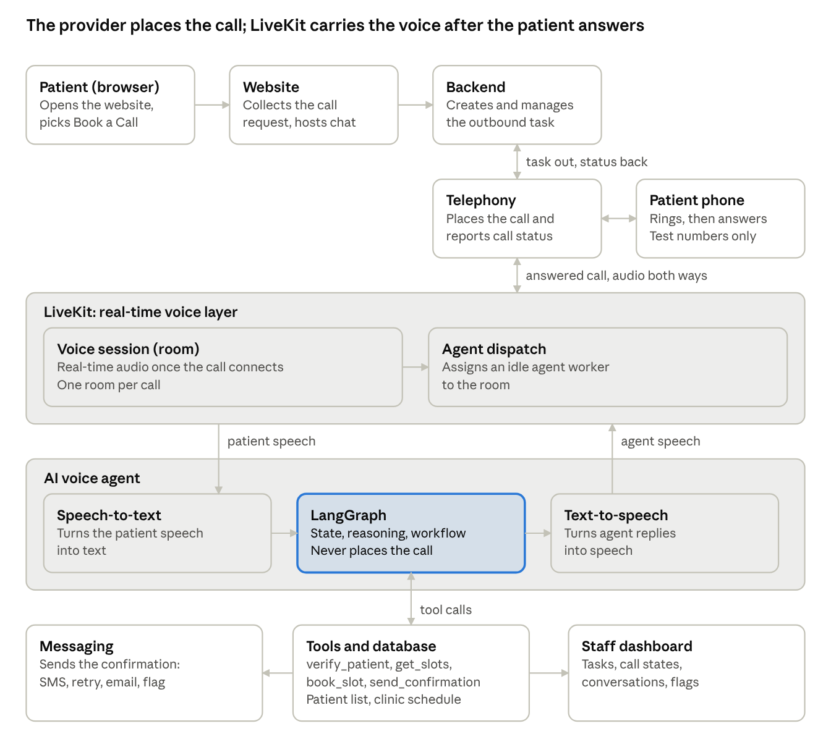
Book a Call architecture · request, call leg, voice session, agent
The telephony provider places and tracks the call. LiveKit starts only after the patient answers, and LangGraph never touches the phone line.
The path is: website request, backend, telephony provider, patient phone. When the patient answers, the call connects to LiveKit and the AI agent. Inside the agent, speech-to-text feeds LangGraph, which uses the tools and database, and text-to-speech returns the voice through LiveKit and the telephony provider to the patient.
How it works:
- The patient submits the Book a Call form. The website sends the request to the backend.
- The backend validates it, creates the outbound call task, checks the dial rules and asks the telephony provider to place the call.
- The telephony provider calls the patient's phone and reports ringing, answered, no answer, busy, voicemail or failed back to the backend.
- When the patient answers, the telephony provider connects the call to a LiveKit room, and LiveKit assigns an idle agent worker.
- The agent introduces itself as automated, and asks for the patient. Only after identity is verified does it discuss the appointment.
- It reads slots, offers alternates, reconfirms, books atomically, confirms in the call and sends the confirmation.
- The call ends, the call state and outcome are logged, and the session is released.

4.3 Chat Booking
Chat Booking (Phase 2) is the second option on the website. It uses the same LangGraph workflow, booking tools and rules as the call: identity check, slots and alternates, reconfirm, atomic booking, SMS/email confirmation and logging. Only the channel changes, and there is no telephony or LiveKit step.

4.4 Identity verification
Channel | When | Rule
Book a Call | After the patient answers and the agent introduces itself, before any appointment or health detail | Full name and date of birth, checked with verify_patient. The number on the form is never proof. After 3 failed date-of-birth tries there is no booking and the case is handed to the front desk
Book a Call, wrong person | A different person answers, or a voicemail picks up | Reveal nothing, end the call, log it, retry later within the rules
Chat Booking | Before booking | Full name and date of birth, as the basic patient identification
The agent never confirms another patient's details. A mid-sentence yeah or mm-hmm is not consent, and a clear yes is needed at the read-back.

4.5 Capacity and call queue
Does an agent wait on a phone line? No. The application starts every call, so no one dials in and no line is held open. The agent session starts only after the patient answers. Idle agent workers are small programs registered with LiveKit, ready to accept a job, and they use no phone minutes while idle.
How many calls at once? Each call is an independent session, so calls run in parallel. The limit is the weakest layer: telephony provider capacity, LiveKit sessions, AI provider limits, or server capacity. We confirm each limit in writing with the provider before promising a number.
When capacity is full: the call task stays queued and is placed when capacity frees up. The patient is not given a busy tone, but the call may start later.
Sizing: concurrent calls = calls per hour x average minutes per call / 60, counting retries as calls. For example, 30 calls in the busiest hour at 4 minutes each is 2 calls on average. Requests arrive in bursts, so we plan for about 3 to 5 times that, which is 8 to 10 concurrent calls. The client should confirm their busy-hour volume.

5. Low-level design

5.1 Book a Call sequence
The sequence below shows one Book a Call request from form submission to confirmation.
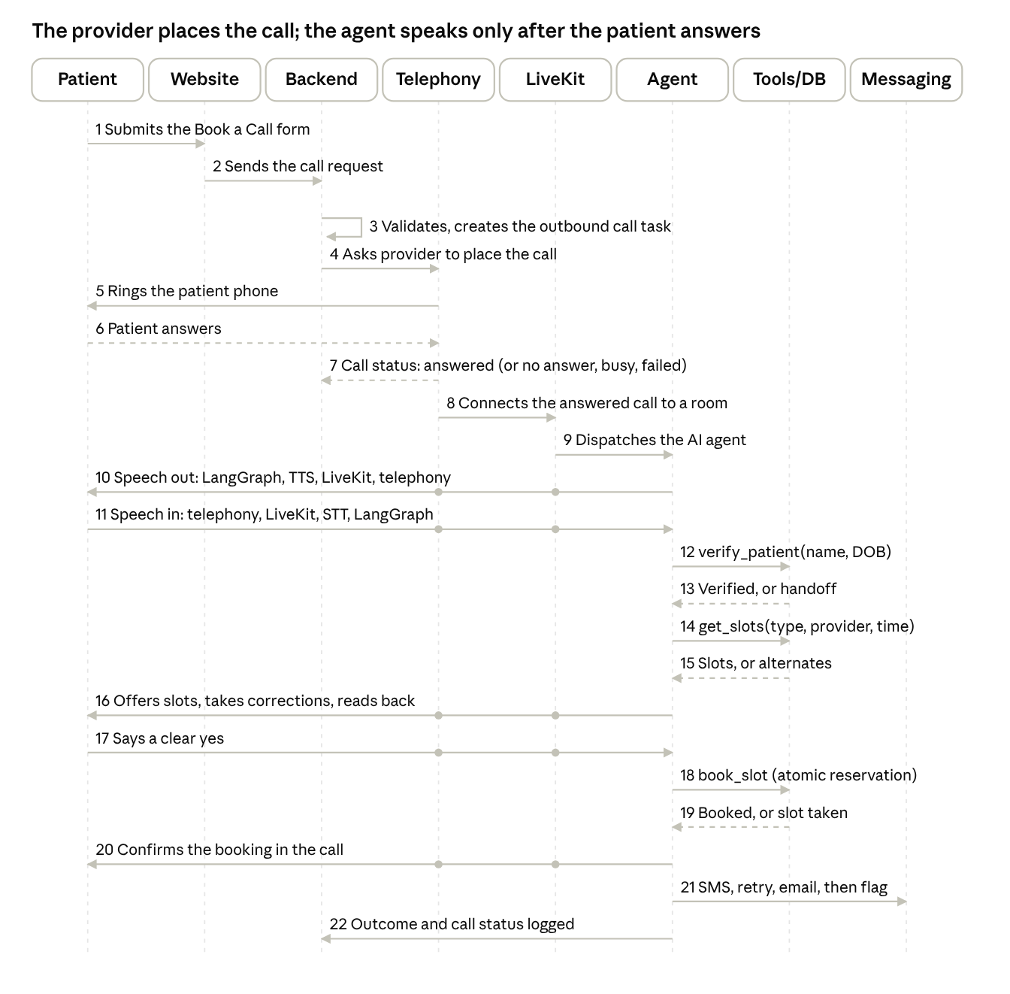
Book a Call sequence · 8 participants, 22 messages
Dashed arrows are replies, and dots mark the layers a voice message passes through. Steps 4 to 7 repeat for each attempt: if the patient does not answer, the backend logs the call state and schedules a retry. Step 13 ends in a handoff after three failed identity tries, and step 19 returns alternates if the slot was taken.

5.2 Call task and call outcome flow
The flow below shows the call task, the dial rules and what happens to each call outcome before the conversation starts.

5.3 Booking conversation flow
The flow below shows the conversation after the right person answers. Chat Booking follows the same decisions.

5.4 Call states and conversation states
Call states (owned by the backend, from provider status):
State | Meaning
Requested | The form is submitted and the request is recorded
Queued | The call task waits for capacity or the calling window
Dialling | The provider is asked to place the call
Ringing | The provider reports the phone is ringing
Answered | A person answered
Connected | The call is connected to a LiveKit room and the agent is in session
Ended | The call finished, and the outcome is in the conversation state
No answer, Busy, Voicemail, Call failed | Unsuccessful attempts reported by the provider
Retry scheduled | The next attempt is queued within the rules
Retries used | No attempts left, handed to the front desk
Opted out | The patient asked to stop calls, and no further calls are made
Conversation states:
State | Meaning
Started | The session or chat record exists
Identifying patient | Full name and date of birth are being checked
Collecting details | Appointment requirement, type, provider preference, date and time
Suggesting slots | Available slots or alternates are being offered
Reconfirming | The read-back is waiting for a clear yes
Booked | The slot is committed
Confirmation sent | SMS and/or email delivered
Wrong person, Abandoned, Failed, Handed to front desk | End states, each with a reason in the log
Every change of state is logged with date and time.

5.5 Tools and data
Tool | Input | Output | Notes
Call task (backend) | Validated form request | Task id, call state | Records the authorising request, checks the dial rules, and returns the same task for a duplicate submission. Records opt-outs
verify_patient | Full name, date of birth | Verified or not | Reads the sample patient list. 3 failed tries end in handoff
get_slots | Appointment type, provider, preferred time | Available slots, or alternates | Reads the sample clinic schedule. Never changes it
book_slot | Verified patient, chosen slot | Booked, or slot taken | Reserved atomically with a unique constraint or row lock, so two patients cannot get the same slot. A repeated request returns the same result
Send confirmation | Booking details | Delivery status | SMS, then retry, then email, then flag. A simulated failure switch forces the failure path for scenario 8
If a call drops after the booking commits, the booking stands and the confirmation is still sent. A call that drops before the commit leaves no booking.

5.6 Failure handling
Failure | Behaviour
No answer | Log No answer, schedule a retry within the rules, then Retries used and front desk
Busy | Log Busy and retry in the same way
Voicemail | Leave no appointment or health details, log it, retry later
Wrong person answers | Reveal nothing, end the call, log it, retry later
Identity not confirmed | Do not book, log it, hand to the front desk
Requested slot unavailable, or taken before booking | Offer alternates
Call failure (provider error, network, call drops) | Log Call failed, retry within the rules. A call dropped before the commit leaves no booking
Patient asks to stop calls | Record the opt-out, end the call politely, make no further calls
Booking or system failure (schedule source, database, LLM or speech timeout) | Hold message, one retry, then a polite message and handoff. No half-made booking
SMS fails | Automatic retry, then email, then flag
Speech not understood | Ask again, then offer handoff
Patient tries to override the rules | The agent ignores it and continues the flow
Patients hear a polite, plain message and a next step. Staff see what went wrong and where. Technical details go to the log.

5.7 Logging
- The backend logs each call task with its call states and attempts. The agent logs each conversation state change.
- Each step logs input, output, time taken and result. For example, Understand logs what the patient said and the intent captured, Suggest slots logs the request and the slots offered, and Confirm logs the booking and the SMS/email delivery status.
- Staff open any call or conversation to see its full timeline and transcript, and filter and sort the bookings, calls, conversations and log screens.

